NMOS Inverter with NMOS Load

NMOS Inverter with NMOS Load

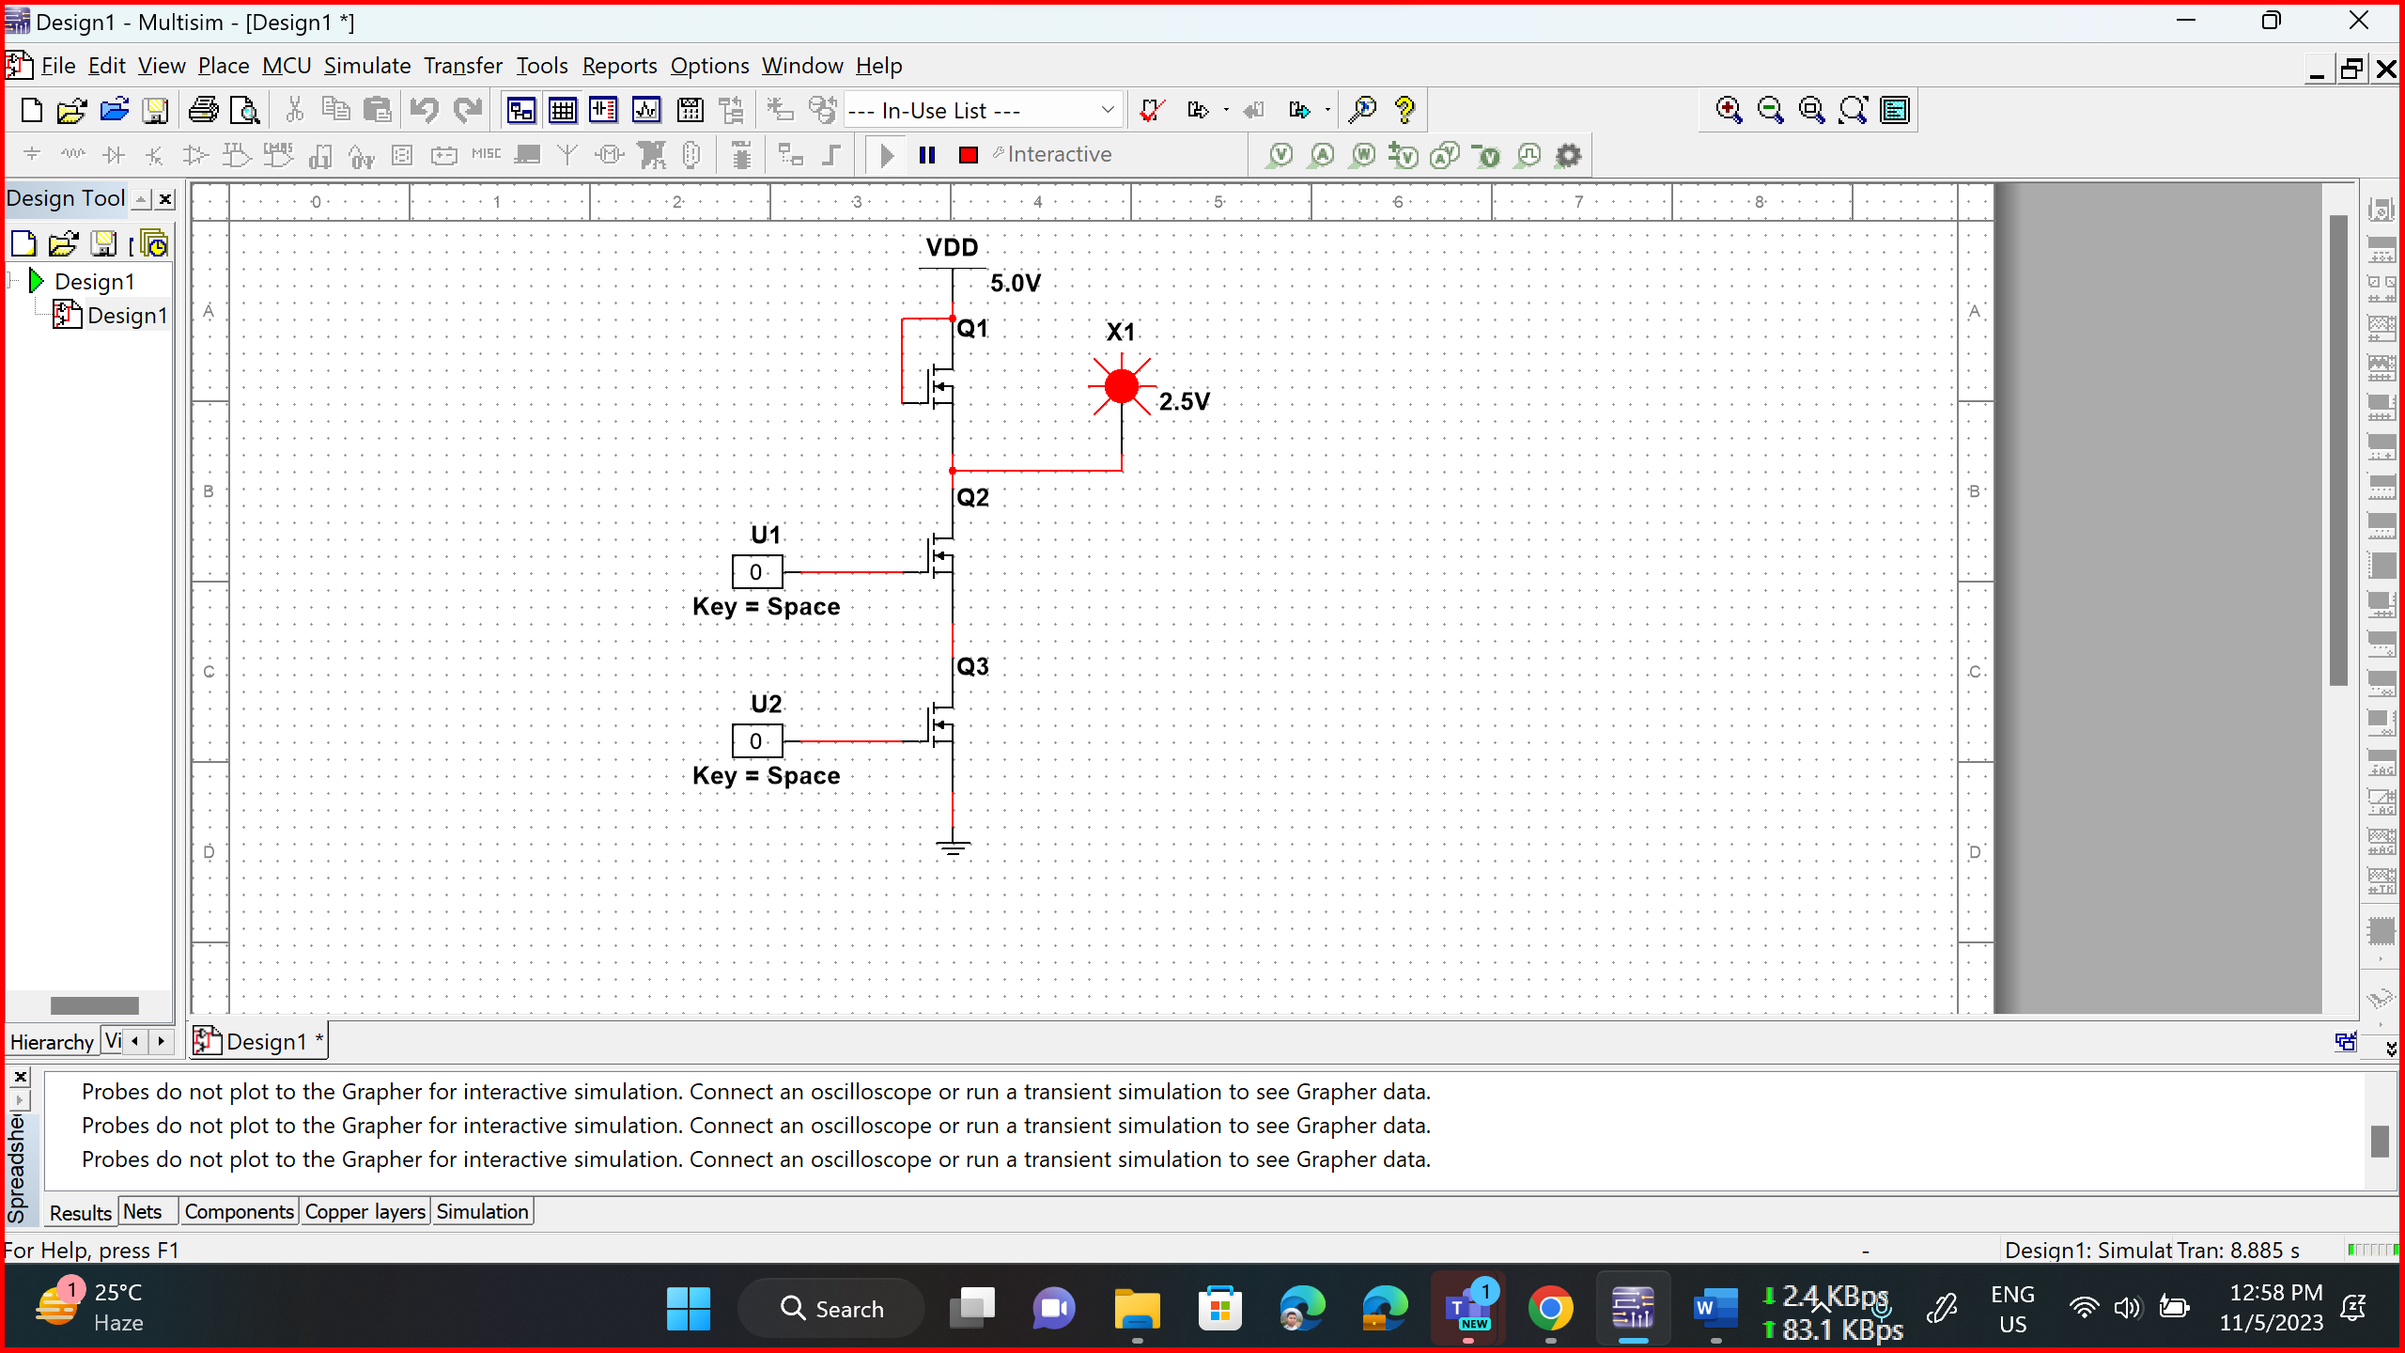

NMOS NAND Gate

NMOS NAND Gate

NMOS NAND Gate

NMOS NAND Gate

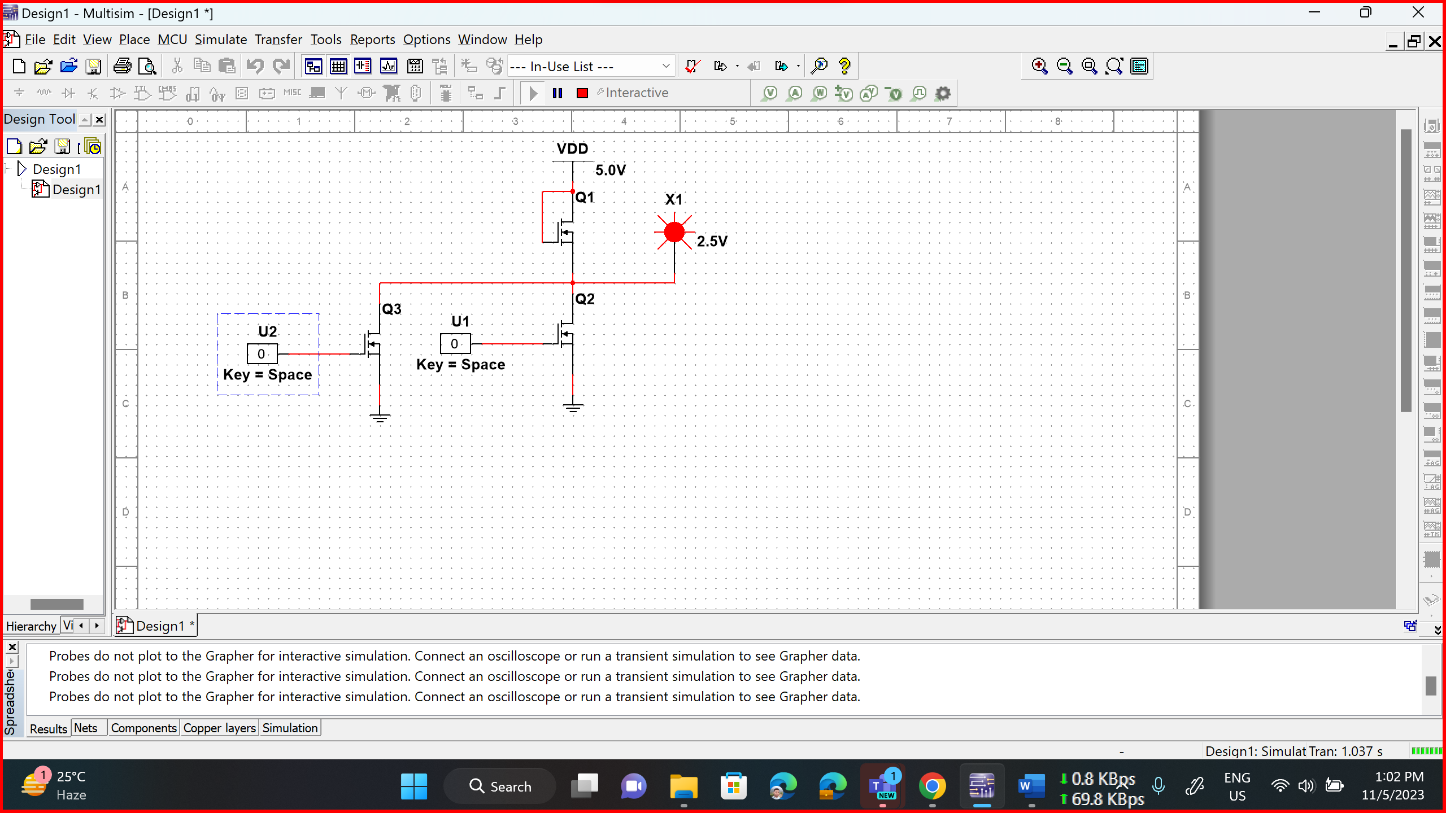

NMOS NOR Gate

NMOS NOR Gate

NMOS NOR Gate

NMOS NOR Gate